School Counseling Program Newsletter
Shandrai Silva, School Counselor | May 2018

Counselor Message  Happy May! As we enter the last few days of the school year, I am excited to say it has been another fabulous school year at Hawks Nest STEAM Academy.  In April, our students participated in another successful Career Day at Hawks Nest STEAM Academy. We had 50 companies/businesses represented as either Career Day Presenters with our lower grades or Career Fair Participants with our upper grades. The students were able to learn about STEAM related careers firsthand as well as engage in career and college related activities.  This month in classroom guidance, we will continue with our social emotional learning lessons.  Our lower grade students had an opportunity to be Bucketfillers this month by making cards for area nurses and healthcare professionals during Nurse Appreciation Week. Thank you K-2 students! You Rock!  As we approach the end of the school year, students are encouraged to keep working hard and to do their best always.  How to See the School Counselor  Classroom guidance classes weekly or biweekly based on grade levels specials schedule. Small group and individual counseling by self -referral, parent referral, teacher referral, administrator referral or counselor initiated.  Contact School Counselor at 704-866-8467 or sosilva@gaston.k12.nc.us | Home of the Hawks      May is Mental Health Month  https://healthykidstoday.org/2018/05/11/may-is-mental-health-awareness-month/  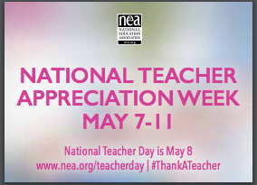   | Character Education  “We’re Soaring with Good Character”  _____________________________  The character trait of the month is Courage. Courage is doing the right thing even when others don't; following your conscience instead of the crowd; and attempting difficult things.  ________________________________  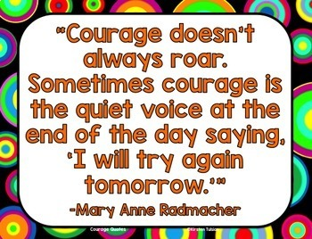  Some Ways You Can Show Courage  1. Do the right thing, even if others are not.  2. Bravely deal with your daily challenges.  3. Be willing to try new things, even if you might fail.  4. Tell the truth regardless of the consequences.  5. Face your fears and work to overcome them.  6. Admit your mistakes and learn from them.  7. Do not give into negative peer pressure.  http://schools.cms.k12.nc.us/beverlywoodsES/Documents/Marchcourage.pdf  “Intelligence plus character- that is the goal of true education.”  Dr. Martin L. King, Jr.

